Instructions for the use of the Imaging Workflow java application:
- Open program using desktop shortcut created during installation
- Go to Working Folder tab, and browse to WorkingFolder where the app was installed (ex. C:\Users\TCN1\Documents\WorkingFolder if app was installed to the documents folder of user TCN1); this will only need to be done the first time, but should be checked each time you open the program.
- Go to Select Data Sources tab, and browse to AquaticTaxa.tab (will be under same folder app was installed); this file contains the scientific names of relevant taxa to the project (plants only) in alphabetical order.
- The Persist Meta Data tab allows the user to set selected fields to persist from record to record (e.g. if you are imaging a stack of specimens all with the same scientific name, you can check the scientific name box)
- Go to Enter Data tab.
- Hit New Session button to start entering data.
Setting up the camera (Canon EOS 5D or 6D) utility for data entry
- Open program EOS Utility on desktop
- Hit the Preferences button
- Go to the Destination Folder tab
- Click browse
- Make the destination folder workingfolder/processing
- Hit OK; hit OK
- Click on Camera Settings and Remote Shooting
- Click the round button in EOS utility to take picture
Entering data
- Go back to Imaging Workflow
- Place cursor in the barcode field and scan the barcode with your reader
- Enter data into all fields that you can (if no collector number, put “s.n.”); use “Unknown” for collector if missing.
- Hit Enter
- Take another picture and repeat

Uploading to FileZilla
- Open and log onto FileZilla
- Navigate to your Destination folder under WorkingFolder (on left side of window)
- Folders will be created with the date and workstation in this Destination folder
- Navigate to the folder for your institution(this folder has already been created for you) and open it (found on right side of window)
- Drag folders from Destination on the left to aquatic on the right (see picture at end of this document).
- Once all folders have been deposited, close program.

Notes
If more than one collector is listed, please type all listed collectors into box (we use first and middle initial and last name) with each collector separated by a semicolon
The camera will take 2 pictures (CR2 and JPG). The JPG is what we are using for the project, and these files will go into the destination folder, and the CR2 files will be placed into a separate folder for you to do with as you please.
Check the quality of the photos at the beginning of your session and after every 15 or so to ensure the process is going smoothly.
The AquaticTaxa.tab file can be edited if a scientific name does not exist on the list. Just open the file, add the name in its proper alphabetical location (if it is only been identified to Genus, you may just add the Genus to the list). Save the file, and then go back to select data source tab and reselect the file.
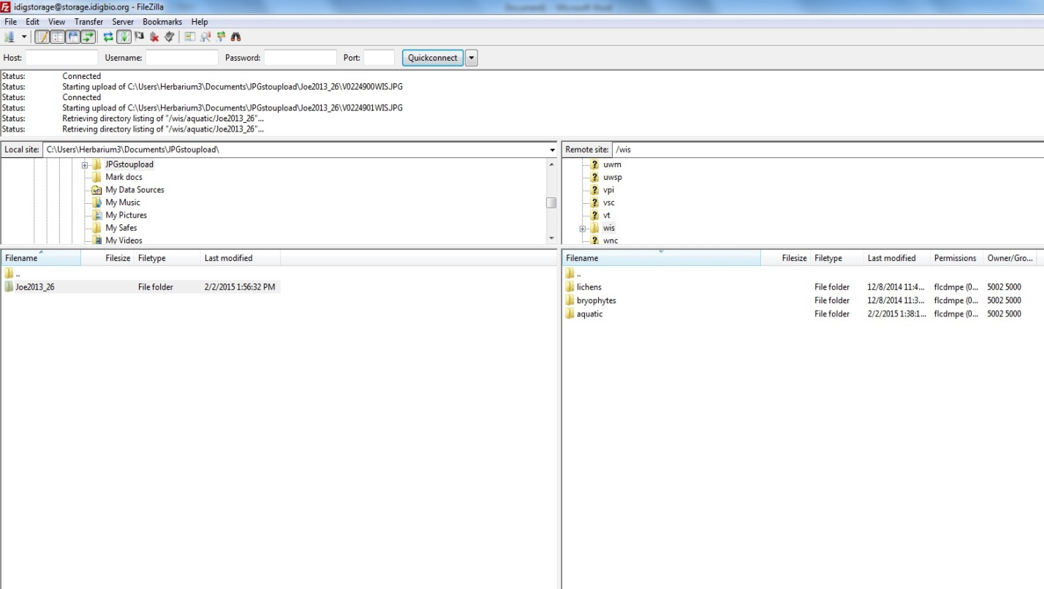
Picture of the FileZilla Screen

